M. G. Science Institute, Ahmedabad
Autonomous | Affiliated to Gujarat University, Ahmadabad

(Managed by The Ahmadabad Education Society)
Department of English

Bachelor of Science (Hons.)
B.Sc. (Hons.)
(Effective from Academic Year 2024-25)

Semester-III
Indian Knowledge System
(AEC-235)

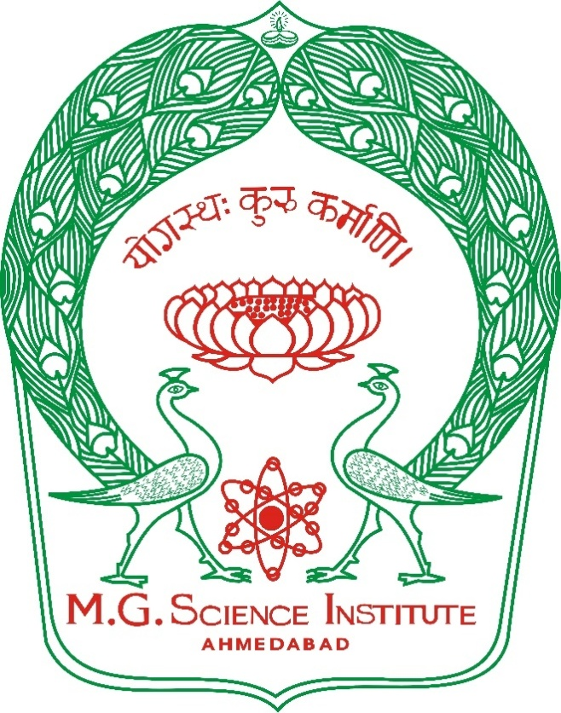

M.G.SCIENCE INSTITUTE (AUTONOMOUS)

Ability Enhancement Course in English
Ability Enhancement Courses for Undergraduate Programme
B.Sc. Semester-3
(According to National Education Policy–2020)

Ability Enhancement Course (AEC) 235 Title: English for Excellence–I

Course Code: AEC– 235 Course Credits:02

Title: English for Excellence–I

Subject | English |  |  | Semester |  | 01
Course Title | English for Excellence-1 |  |  | Course Credit |  | 02
Category | AEC course |  |  | Course No. |  | 235
Course Code | AEC235
End Semester Examination |  |  |  |  |  | 25 Marks
Programme | Teaching Hours | Category | Credit | Internal Marks | External Marks | Practical/ Viva  Marks | Total Marks
B.Sc. | 40 | AEC  Course | 02 | 25 | 25 | 15/10 | 50

SEMESTER–III
Ability Enhancement Courses AEC-235: English for Excellence
(With Effect from AcademicYear2024-2025)

------------------------------------------------------------------------------------
Andragogy: Classroom Lectures, Group Discussions, Role-Plays, Skill- based Practical Exercises, etc.

Learning Objectives:
- To encourage students to read stories and poems in English.
- To enhance grammatical competence to encourage students to communicate in English.
- To enhance the students’ reading comprehension skills through prose passages.
- To develop the students ’LSRW skills in English

Course Outcomes: On successful completion of the syllabus, the students will be able to:
- To form correct sentences in English by acquiring basic competence in grammar.
- To speak and write English for everyday communication needs.
- To access information in English necessary for academic, personal and professional development.

Syllabus:
Unit I  (15Hours) | Text: Glimpses of Infinity ( Orient Black swan Publication)  - ‘After Twenty Years’ by O Henry  - ‘The Magic Beard’ by R. K. Narayan  - ‘The Village School Master’ by Oliver Goldsmith  - ‘Middle Age’ By Kamala Das
Unit II  (15Hours) | Grammar  - Subject-Verb Concord  - Active and Passive Voice  - Degrees  - Prefixes and Suffixes  - Synonyms and antonyms  Paragraph Writing  - The passage should be of 150-200words.  - The evaluation should measure the student’s ability to express the main ideas, relevant facts and arguments and the logical and meaningful development of the passage.  Vocabulary(Textual Glossary)
UNIT-III | Practical  - Listening Comprehension  - Describing Scientific experiments  (No examination will be conducted for the practical work)

Pre-requisite:
- Students should have a primary understanding of the English language and basic grammar.

Co-requisite: Basic English vocabulary, basic sentence structure, basic grammatical terms, basic LSRW skills.

Modes of Evaluation

- Continuous and Comprehensive Evaluation(CCE)-(25Marks)
  - Mid-Term Evaluation:20Marks
  - Assignment:05Marks
After completion of the syllabus, the faculty member will conduct mid-term evaluation. The concerned faculty member will decide the mode of mid-term evaluation from the following:

- MCQ Based Examination(Online/Offline)
(OR)
- Any one from the following:

- Open Book Exam
- Practical Exam
- Essay/Article Writing
- Quizzes(On/Offline)
- Objective Test
- Class Assignment
- Research/Dissertation
- Case Studies
- Report Writing
- Interviews
- Poster Presentation
- Seminar
- Paper Presentation
- Viva Voce/Oral

(OR)
- Descriptive Examination (Time Duration:45Minutes)

Note: Structure of the Question Paper for Descriptive Examination (Time Duration: 45 Minutes, Marks: 20)
Q-1.Answer any three questions in brief:(out of five)(From Unit –I) 06
(OR)
Write short note on any one of the following:(out of three)(From Unit–I)
Q-2.Do as directed:(From Grammar: Unit–II) 09

- Semester End Evaluation(SEE)–(25Marks)

Modes of Evaluation | Maximum Marks | Minimum PassingMarks
CCE | 25 | 09
SEE | 25 | 09

Total No.of TeachingHours:30Hours Unit – I: 15 Hours
Unit–II:15 Hours

Credit Distribution: TotalCredits:02 Credits Lecture: 1 Credit
Practical:1 Credit

Recommended Reading:
  - Oxford Practice Grammar(Advanced)-George Yule–OUP
  - Advanced Grammar in Use-Martin Hewings- Cambridge University Press
  - English Grammar for Students-Anne Seaton and YHMew-Learner’s Publishing
  - A Practical English Grammar- AJThomson and AV Martinet– OUP
  - Better English- Betty Kirkpatrick-Geddes and Grosset
  - Contemporary English Grammar Structures and Composition-David Green -Trinity Press
  - Success with Grammar and Composition-K R Narayana swamy-Orient Longman

